SRM upgrade: from 8.2.0.1 to 8.2.0.2

|  |  |  |
| --- | --- | --- |
| wnpapessicsrm01 | 10.44.117.22 | SRM Server for RC |

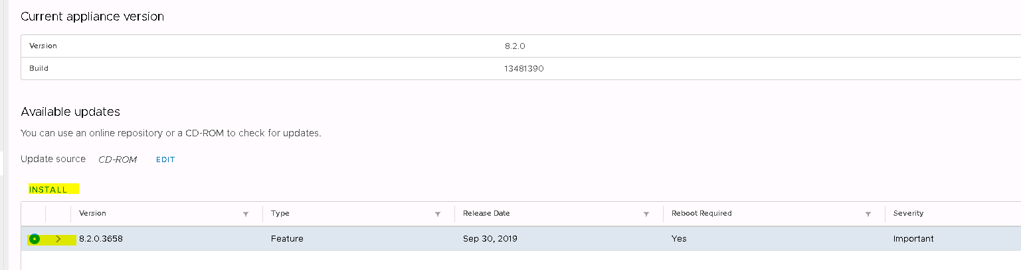

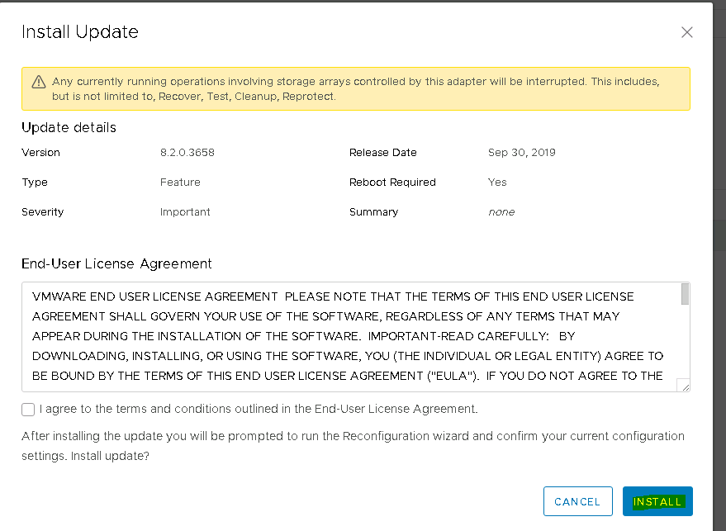

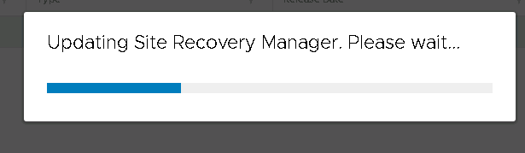

After upgrade , you will lose the connectivity

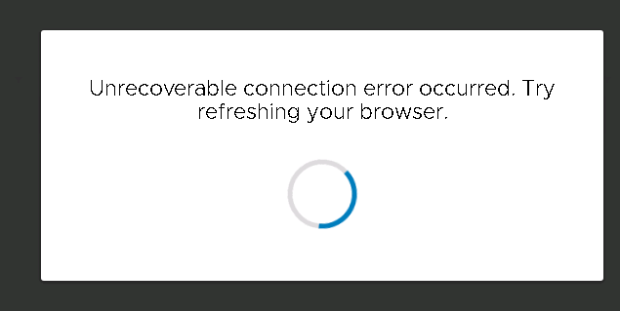

It will load automatic

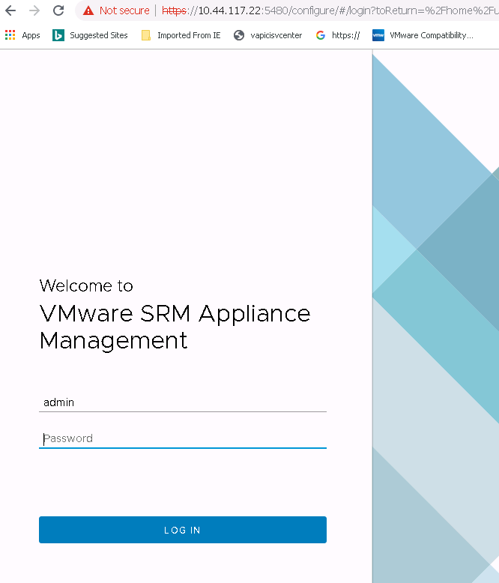

Now go to summary page , new version we will see but need to reconfigure SRM as per pop-up, click on reconfigure

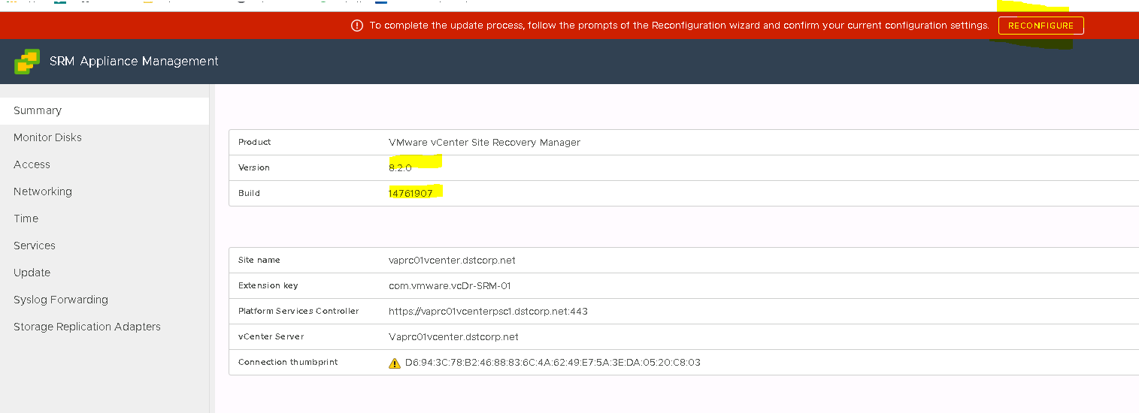

PSC name it will take automatic, give credentials of administrator@vsphere.local

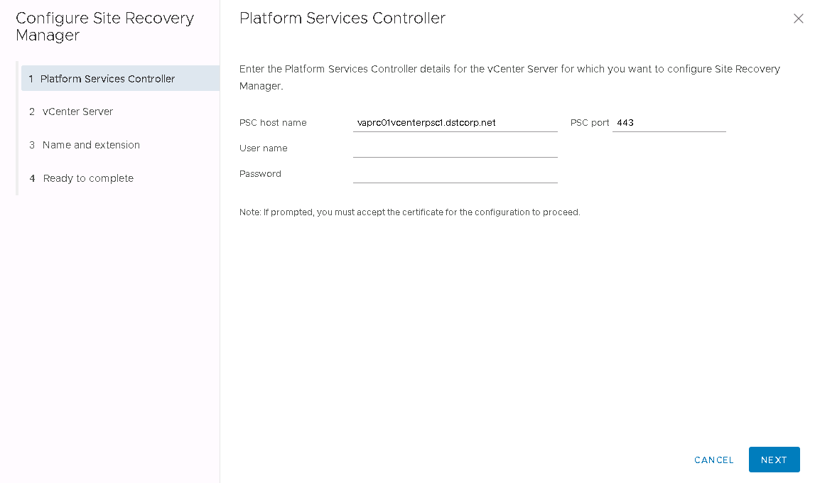

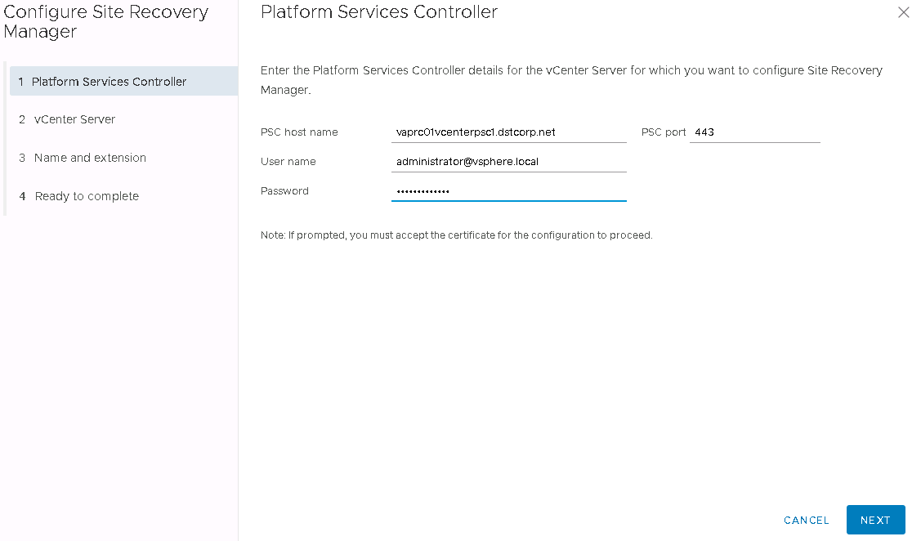

Click connect

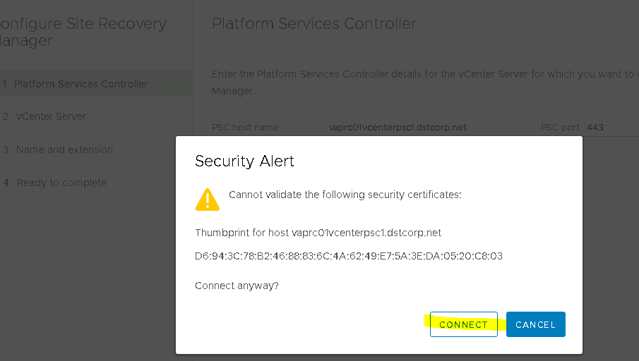

Choose vcenter server—it takes automatic click next

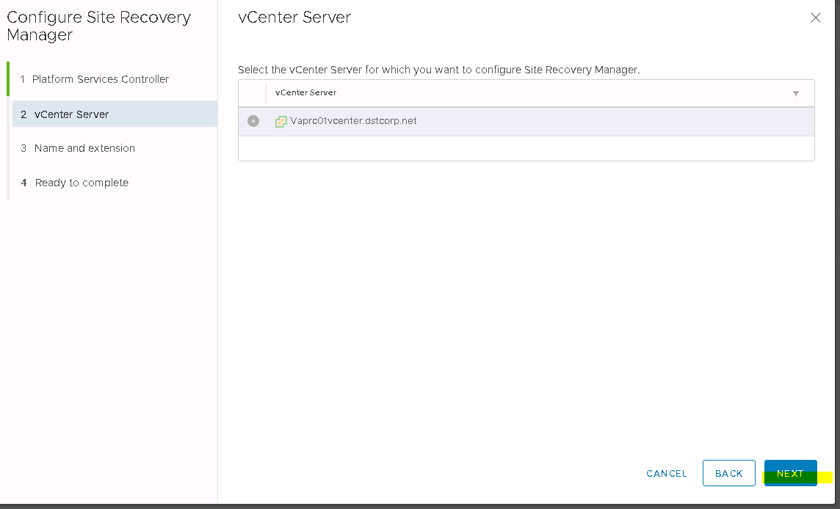

Click connect

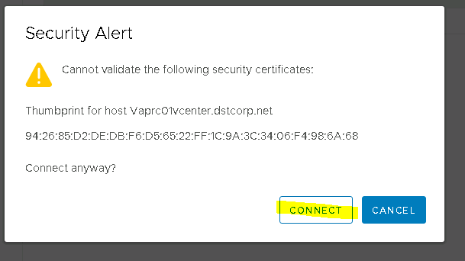

Validate automatic loaded details

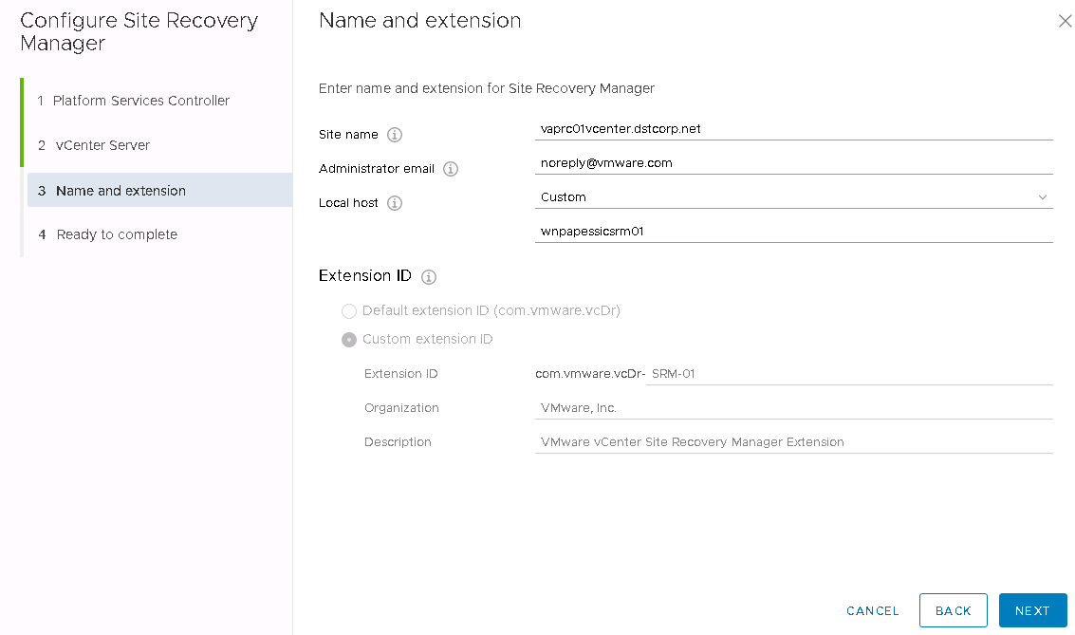

Click next and finish

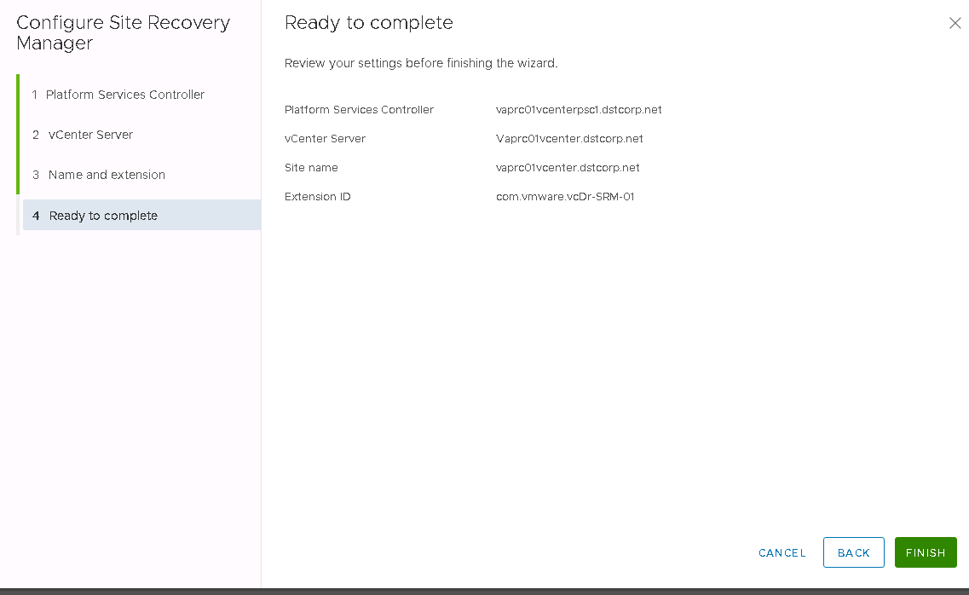

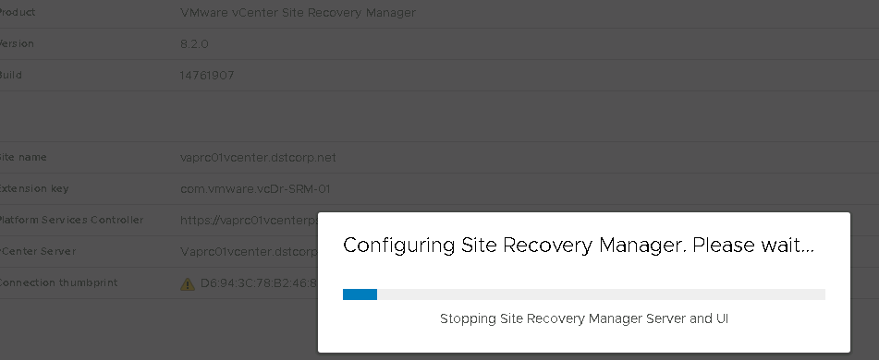

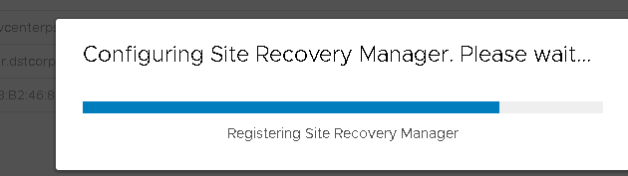

Red highlited popup will be gone from Summary tab, once it refresh page

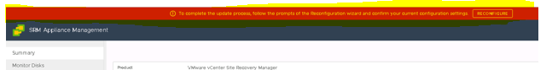

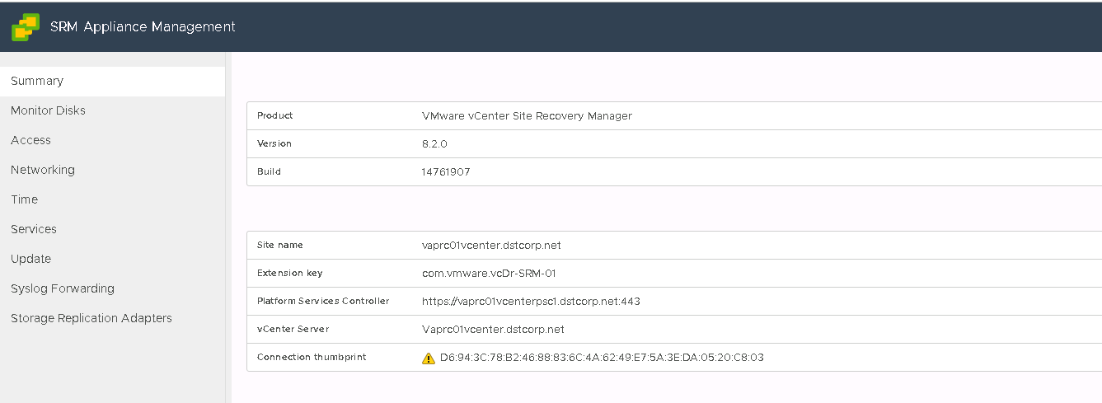

Now Replication Server and Replication Appliance upgrade process.

First need to do Replication Server than repeat same steps to Replication Appliance

vaprc01vrepsrv01 (10.44.117.52 )--- Replication Server

login to VC where Replication Server deployed

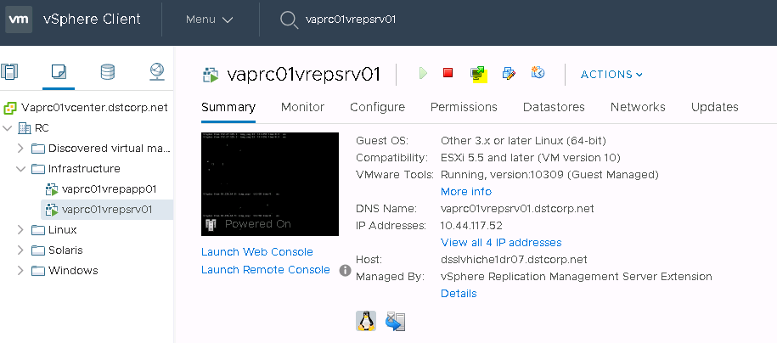

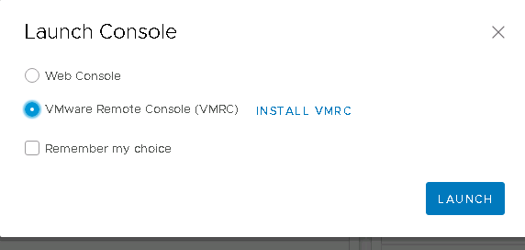

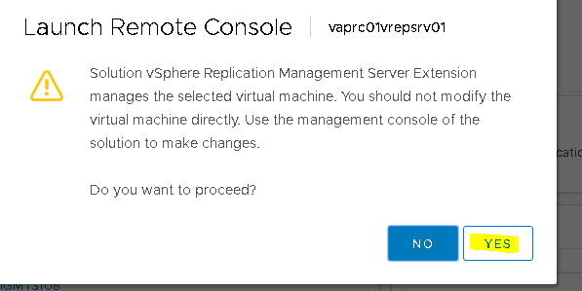

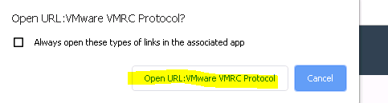

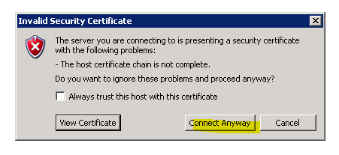



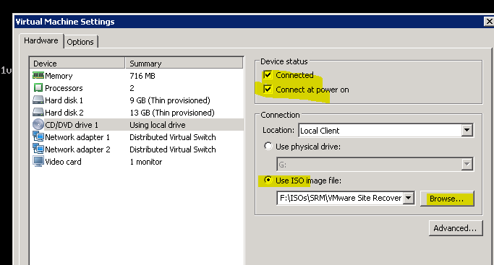

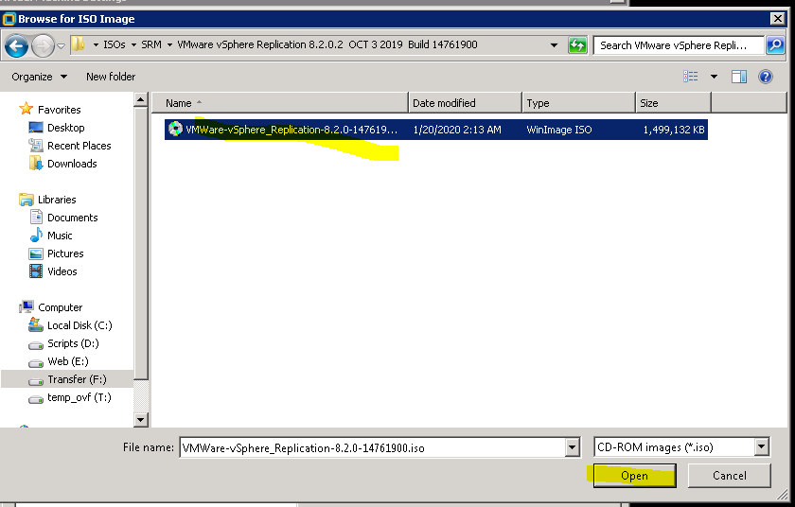

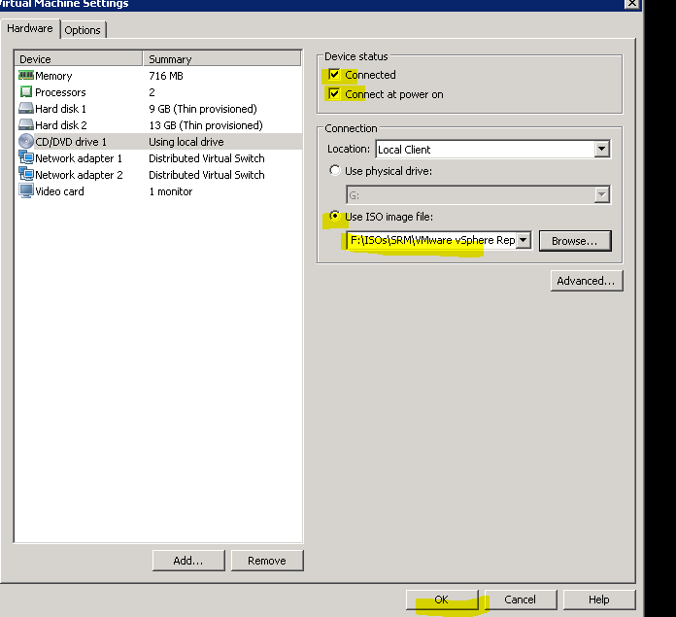

CD rom indicates green means ISO connected



Now Login into VAMI of replication server

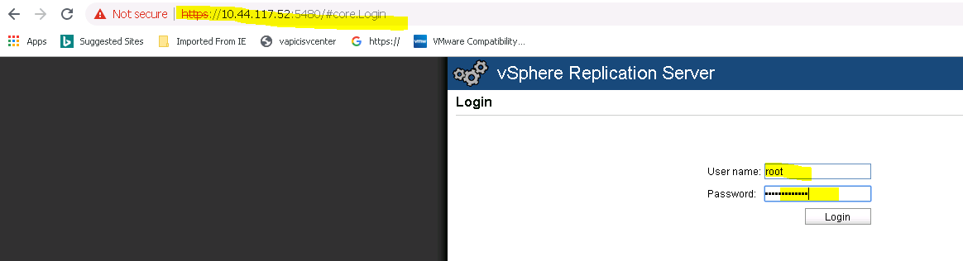

Go to update tab

Check existing version running version

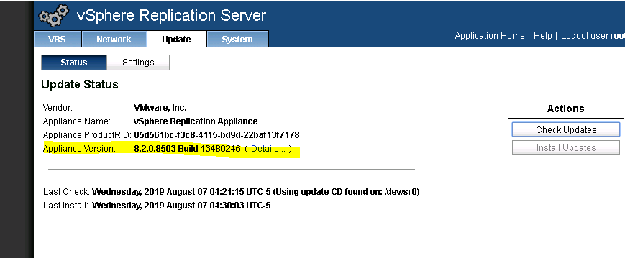

Now go to setting use CD-ROM

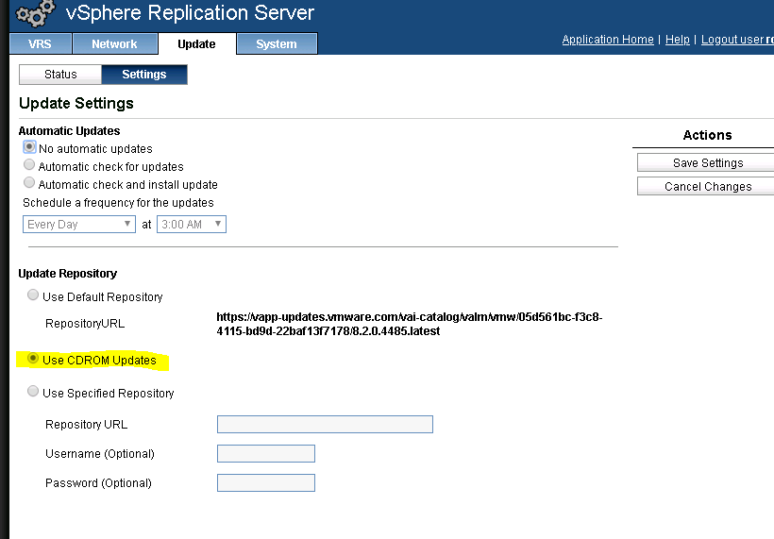

Click on check updates

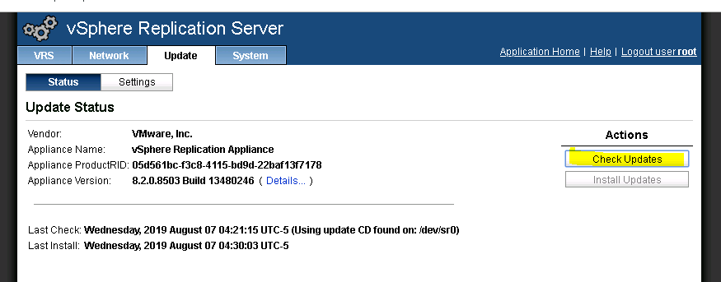

Available updates it will show new version and click Install Updates

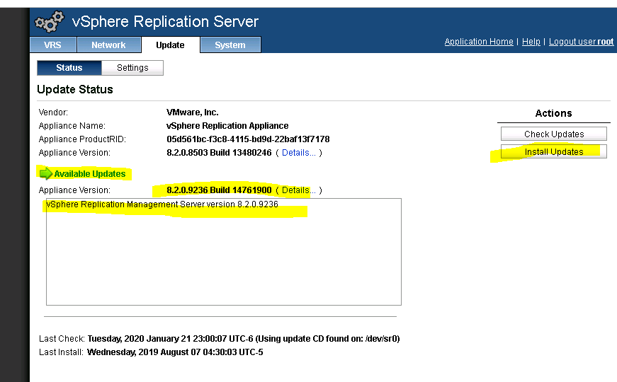

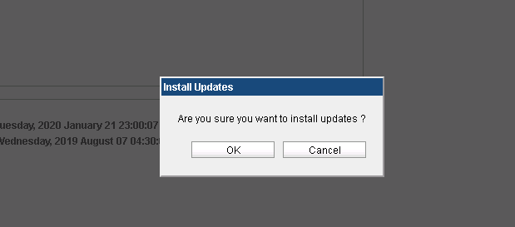

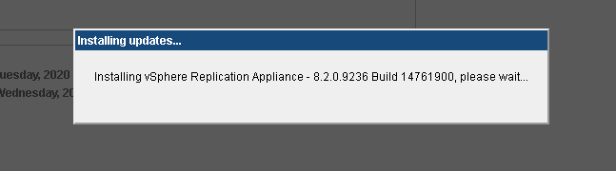

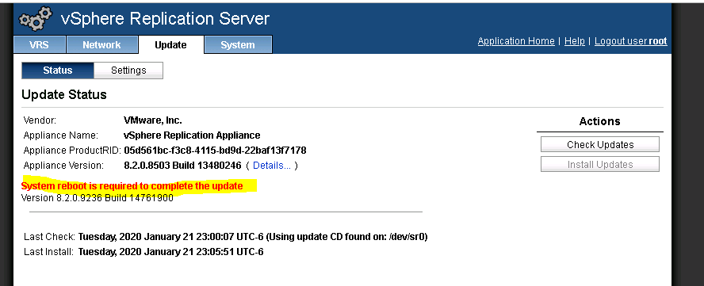

Click reboot

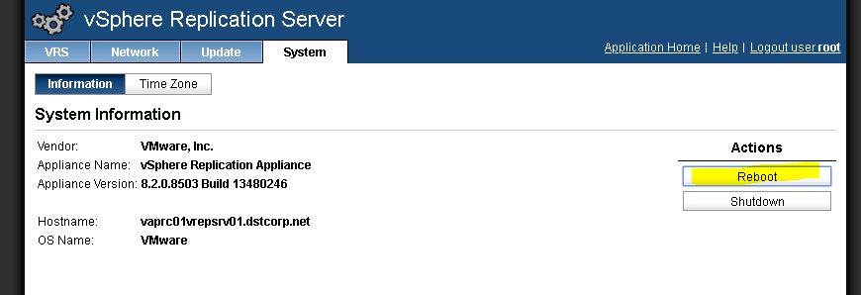

Now repeat same steps for Replication Appliance (vaprc01vrepapp01) same as Replication Server

After complete , need to validate SRM status and Replication status. For that connect VC –go to Site Recovery

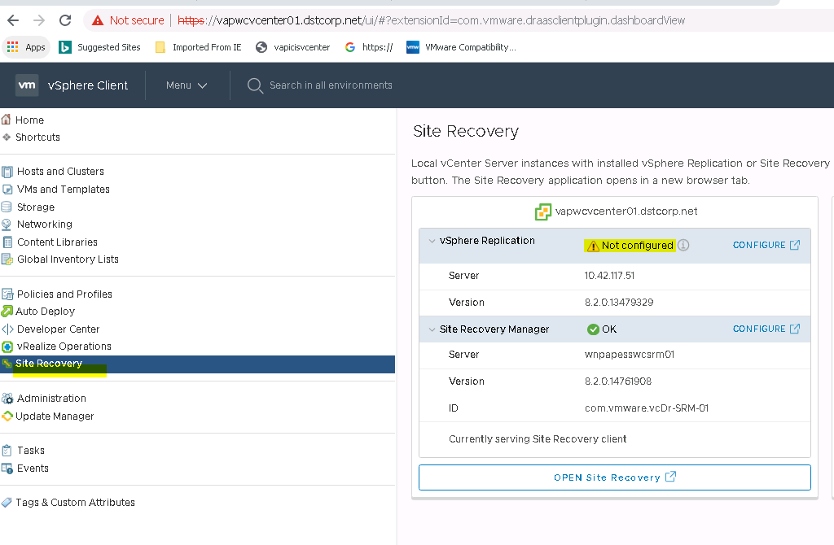

In this screenshot SRM looks fine but replication is having issue. Click on configure for vsphere replication. It will redirect to vami of 10.42.115.51 (

|  |  |
| --- | --- |
| vapwcvrepapp01 | 10.42.117.51 |

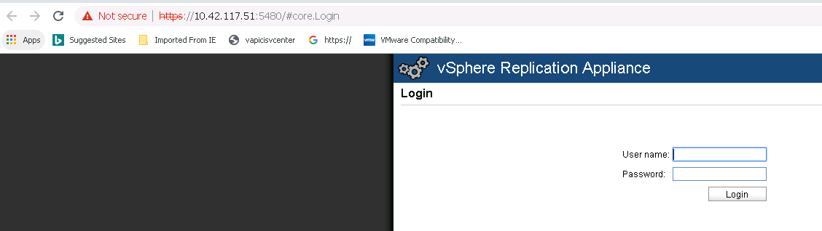

Click on configuration

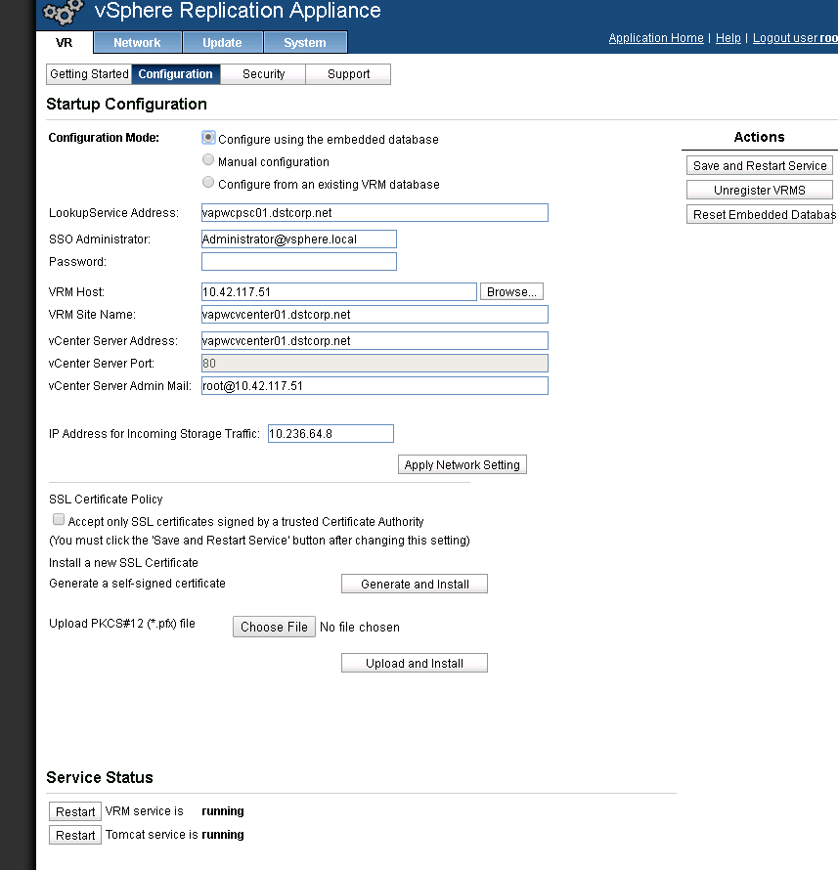

Provide SSO Administrator password and Save and restart services

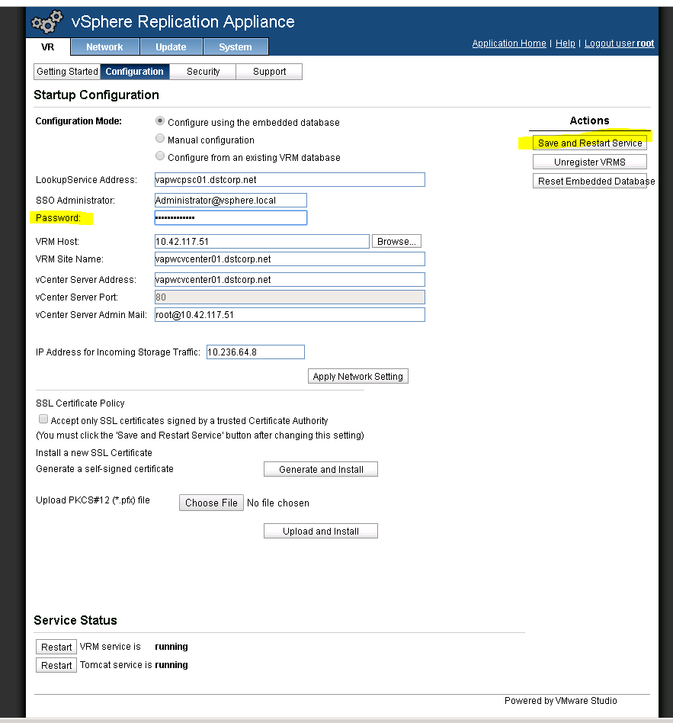

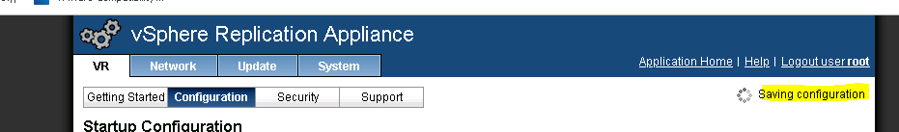

Below both the services will restart

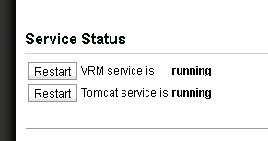

Now come back to vcenter and refresh VC connection.It should both the connection Okay

